Cardiopulmonary Exercise Test Analysis
All CPET analysis is performed post-test, using the Vyntus software to calculate thresholds where possible, and Microsoft Excel for all other measurements.
Abbreviations
VO2 – oxygen uptake
VCO2 – carbon dioxide output
VE – minute ventilation
V-slope – VCO2 plotted against VO2
RER – respiratory exchange ratio
EqO2 – ventilatory equivalent of oxygen. Also reflects the VE/VO2 slope
EqCO2 – ventilatory equivalent of carbon dioxide. Also reflects the VE/VCO2 slope.
PetO2 – end tidal partial pressure of oxygen
PetCO2 – end tidal partial pressure of carbon dioxide
Pre-exercise
For most studies the pre-exercise values are looked at using the 5sec file.
Heart Rate
- CPET report.pdf resting values table (Used only for WITHDRAW/CAMERA MRI)
- 5sec.xlsx: average of the first 2 mins pre-exercise (on occasion may only include up until 1:55 due to exercise anticipation causing early spike in HR)
- BxB.xlsx: average of the first 2 mins pre-exercise
Blood pressure
- CPET report.pdf resting values table
- BP.xlsx
Peak
Heart rate
- BxB.xlsx: the single peak HR value during the exercise time (exclude post-exercise in most instances, may include the HR recorded in the initial 5secs after ceasing exercise)
Watts
- BxB.xlsx: the single peak watts value during the exercise time
Blood pressure
- BP.xlsx: the BP value that was triggered immediately at the peak of exercise OR the BP value that was triggered just before exercise being ceased, which appears post-exercise
Ventilation
- 5sec.xlsx: average the final 30secs of VE measured during exercise
RER
- 5sec.xlsx: average the final 30secs of RER measured during exercise
VO2
- 5sec.xlsx: peak VO2 value from a 30sec rolling average of the test
  - Create a new column in the spreadsheet beside the VO2 column
  - Use the formula =AVERAGE in the cell of the new column beside the first value in the VO2 column, selecting this first value and dragging six cells up (30secs)
  - Drag this formula down to the bottom of the VO2 values
  - Find the peak VO2 value using the formula =MAX
VO2/kg
- 5sec.xlsx: peak VO2/kg value from a 30sec rolling average of the test
  - Create a new column in the spreadsheet beside the VO2/kg column
  - Use the formula =AVERAGE in the cell of the new column beside the first value in the VO2/kg column, selecting this first value and dragging six cells up (30secs)
  - Drag this formula down to the bottom of the VO2/kg values
  - Find the peak VO2/kg value using the formula =MAX
Ventilatory Thresholds
Many discrepancies and controversies exist in the literature regarding the correct terminology, definitions and criteria of the ventilatory thresholds during incremental exercise.

1st Ventilatory Threshold
Primary criteria
- Nadir of the EqO2 graph
Verification Criteria*
- Break point in the V-slope
- Deviation from the 45 degree line fitted to the V-slope graph
- Break point in the VE trajectory
- Steeper RER slope after the threshold

2nd Ventilatory Threshold
Primary Criteria
- Increase in EqO2 while EqCO2 remains stable
Verification Criteria*
- Break point in the V-slope
- Break point in the VE trajectory
- Break point in VCO2 trajectory
- RER of ≤ 1

3rd Ventilatory Threshold
Primary Criteria
- Increase in EqCO2 and a decrease in PetCO2
Verification criteria*
- Further disproportionate increase in VE
- Increase in the VE/VCO2 slope
- RER >1
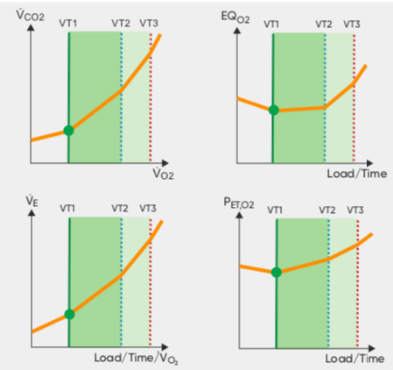
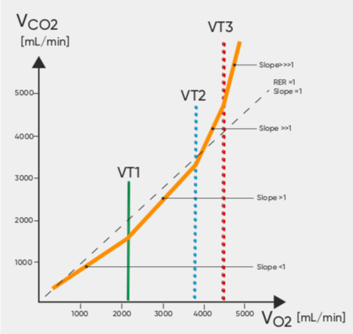
Figure 1: graphical representations of gas exchange criteria for determining the 3 ventilatory thresholds during incremental exercise.

Determining Thresholds on the Vyntus
- The thresholds are determined visually by using the “workflow” tab in Sentry Suite (figure 2) and skipping to the relevant tab (eg. VT1 for the first ventilatory threshold).
- The thresholds are defined by moving the “manual” line to correspond with the primary criteria and verification criteria.
  - When determining the threshold it is important to remember that it is the point immediately preceding the change in gas exchange variables.
- The data points corresponding to the threshold defined by the manual line are shown in the “manual” row of the table above the graphs (figure 3).
- Sentry Suite also provides a 9 panel of cardiac and gas exchange variables that is useful for verifying your thresholds.
They Vyaire Vyntus CPET brochure contains useful information for threshold determination using the software and can be accessed here: https://www.vyaire.com/sites/default/files/2019-04/Special-Edition-CPET_EN_Web.pdf
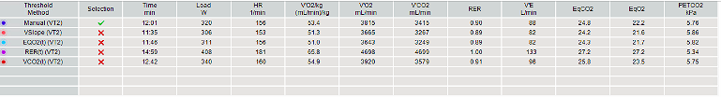
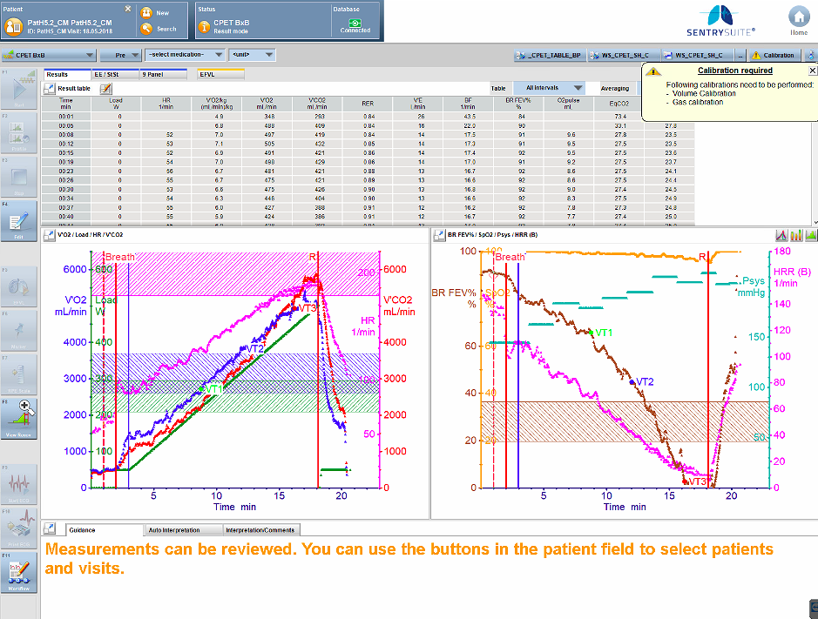
Figure 2: locating the “workflow” tab in Sentry Suite
Figure 3: Locating the variables that correspond to the manually defined threshold in Sentry Suite.

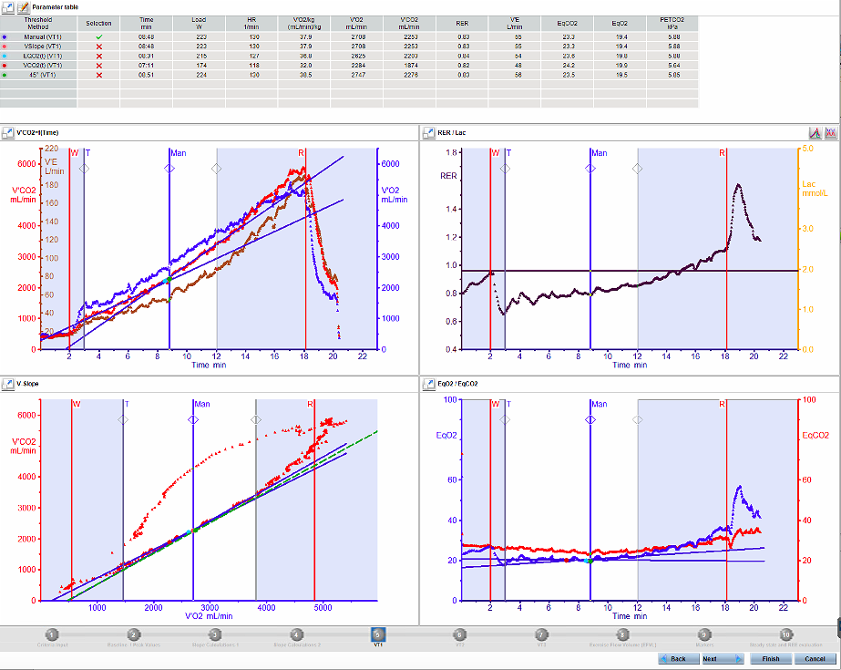

Figure 4: manual determination of the 1st ventilatory threshold in Sentry Suite

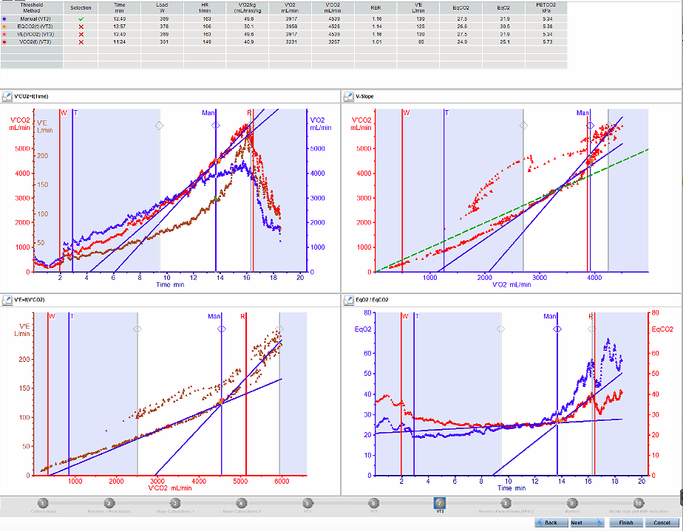
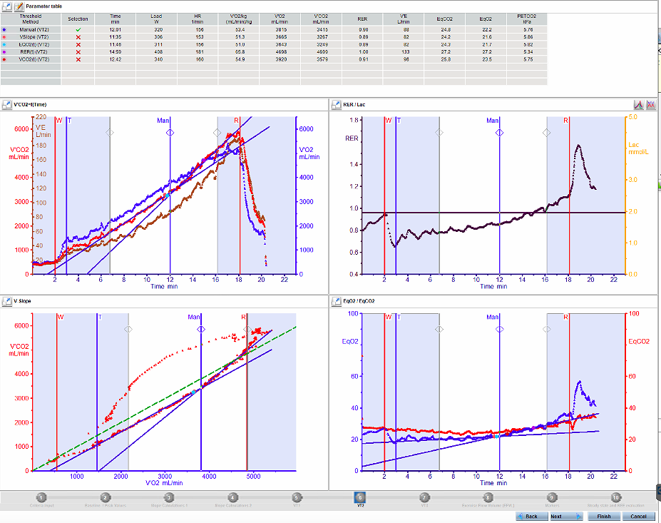
Figure 5: Manual determination of the 2nd ventilatory threshold in Sentry Suite
Figure 6: Manual determination of the 3rd ventilatory threshold in Sentry Suite
Common Issues
- The various criteria are in disagreement
Often the points corresponding to each of the criteria defining the thresholds occur at different times during the test. In this instance it is important to remember the order of precedence of criteria. Individual judgement will need to be employed to determine the point with the greatest agreement between the most important criteria.
- Oscillatory breathing
This pattern of breathing renders determination of an exact threshold prone to inaccuracy. An estimation of the threshold can be made by smoothing the data and using the trends to determine the threshold based on the usual criteria.
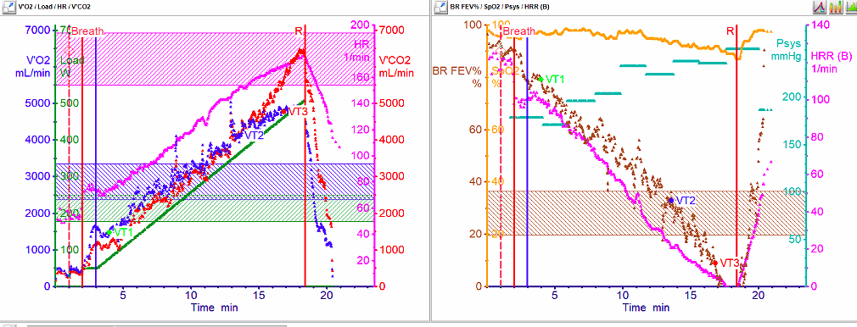
Figure 7: example of oscillatory breathing pattern

- Not all criteria is easily discernible
Occasionally a break in the V-slope or one of the other defining parameters is not apparent. In this case the threshold can be found by using the point at which all other parameters are in agreement.
- Nadir of EqO2 occurs in the warm up
In normal subjects the warm up should be excluded from the analysis. However in the event of deconditioned subjects the warm up workload could represent a substantial relative effort and thus the first ventilatory threshold may occur in the warm up.

VE/VCO2 Slope
The calculation of ventilatory efficiency (VE/VCO₂ slope) following a CPET is done using the Vyntus SentrySuite workflow dialogue.
- Open post-test workflow and proceed to screen for VT3 (Figure 8.)
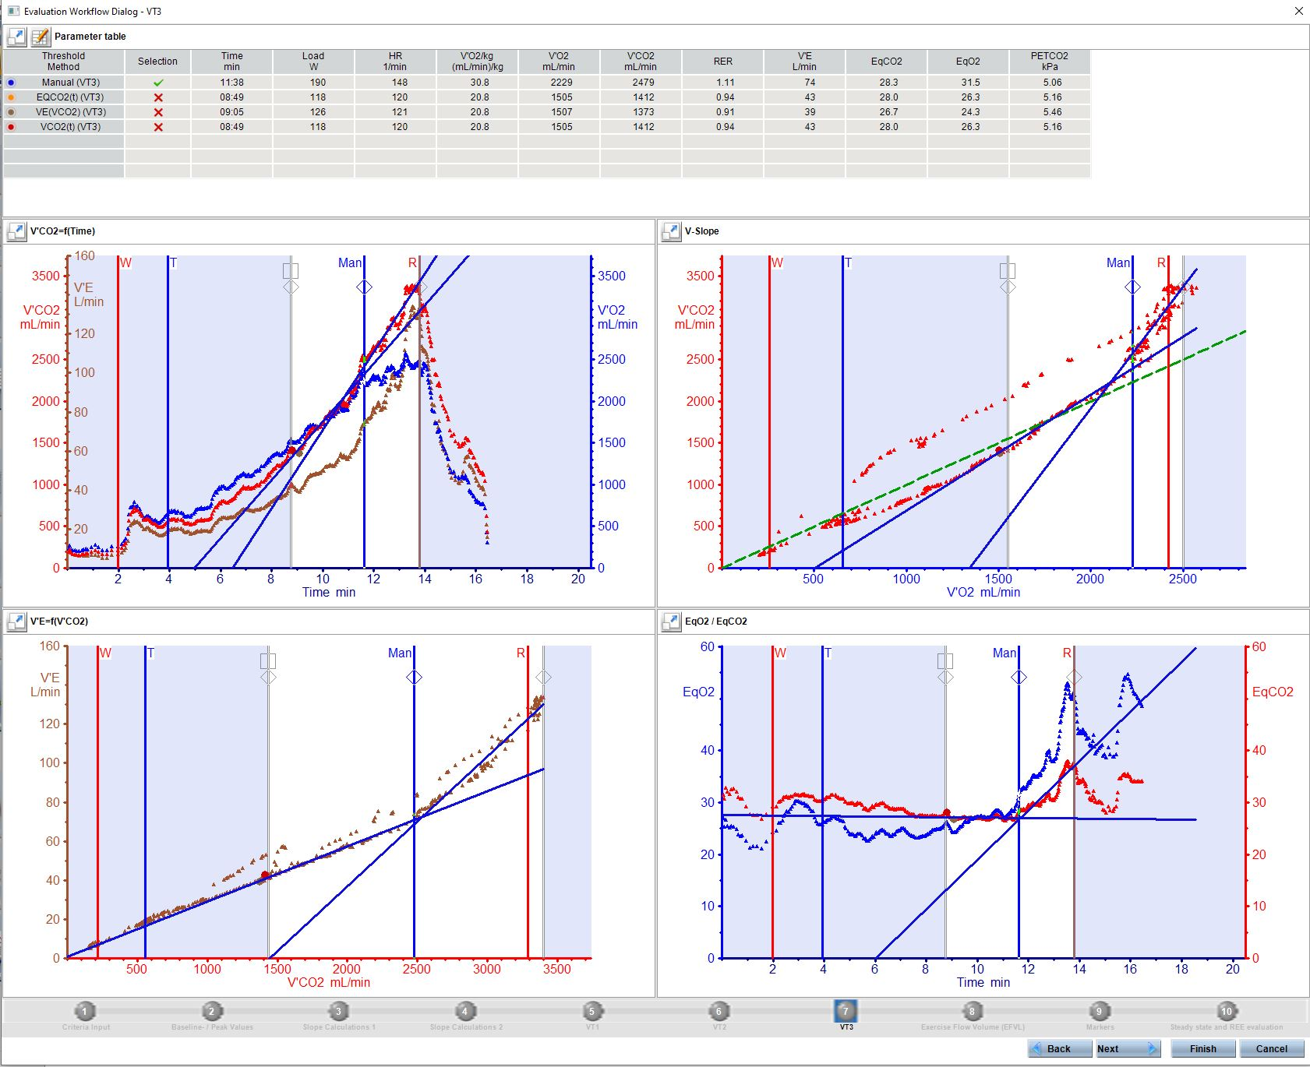
- Use the manual blue vertical line to mark VT3 (refer to ventilatory thresholds SOP for criteria).
Figure 8. SentrySuite post-test workflow: determination of VT3.

- Upon having defined VT3 for the participant, return to ‘Slope Calculations 1’ tab (Figure 9).
  - The top right figure shows the VE/VCO₂ slope.
  - Use the vertical lines to determine the field of calculation for the VE/VCO₂ slope.
  - Lowest values usually included from end of warm-up; however, if participant has relatively poor exercise capacity, their VT3 occurs early in the test, and their VE/VCO₂ slope is consistent from warm-up to VT3, the warm-up data can be included.
  - Highest values to be included are to VT3. Data points beyond VT3 should be excluded (unless you specifically choose to analyse and record VE/VCO₂ slope for entire duration of exercise)
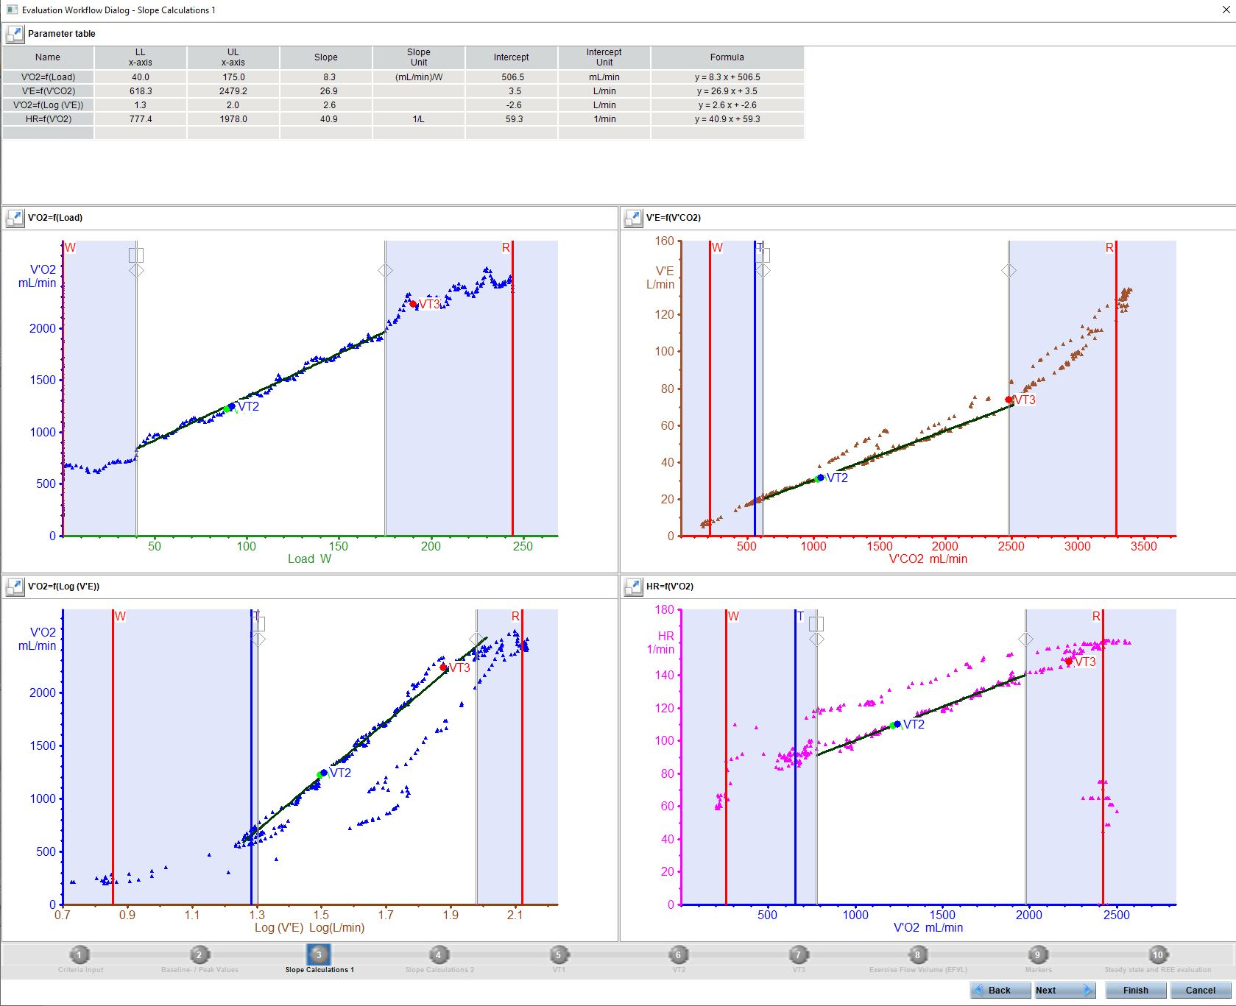
Figure 9. SentrySuite post-test workflow Slope Calculations 1; thresholds for data inclusion
in VE/VCO₂ slope calculation.

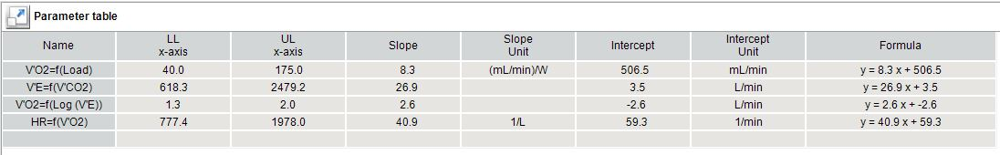
- Record the VE/VCO2 slope value from the Parameter table (Figure 10).
Figure 10. Recording the VE/VCO₂ slope value from the parameter table.

